**FLEET UPDATES VERSION 4.9.1**

**Note: Sample lang ang mga data sa screenshots.**

1. 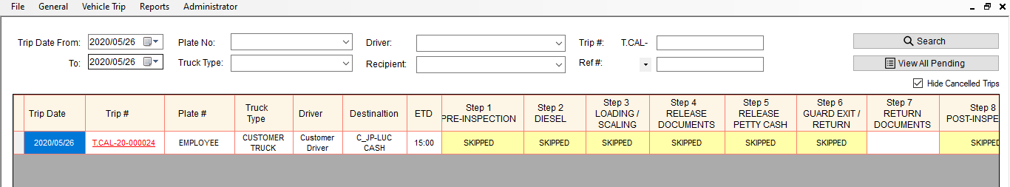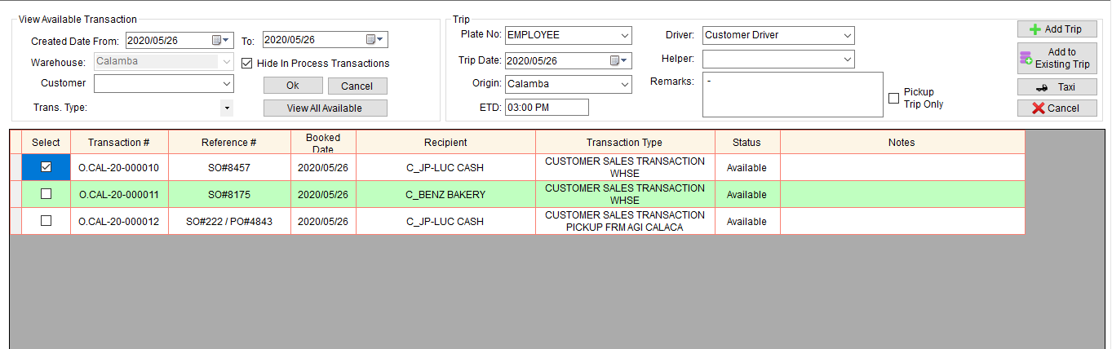If charge to employee, before ang ginagamit na plate# is CUSTOMER TRUCK, ngayon ang gagamitin ng plate# is EMPLOYEE. Then, skipped na lahat ng steps except sa step 7 and 9.
2. Meron ng inches to liters conversion sa Step 2 (Diesel Beginning) at 8 (Diesel Ending)

Step 2. Note: Pwede pa din ung direct input ng sukat in liters.

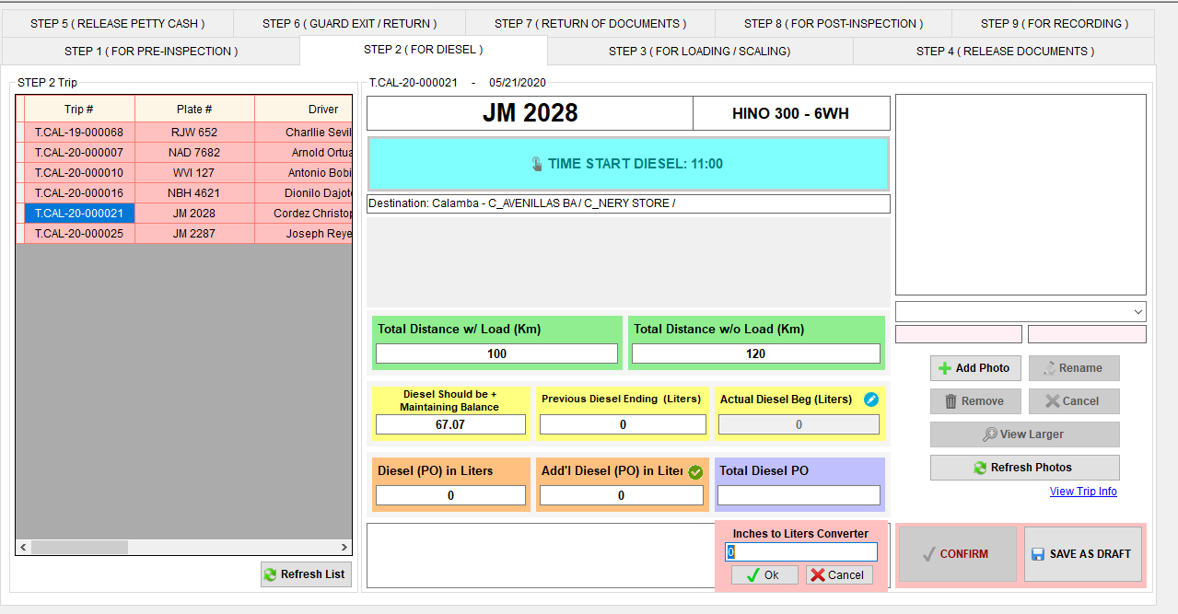

Click this icon to show

the converter

Click Cancel button to cancel the conversion

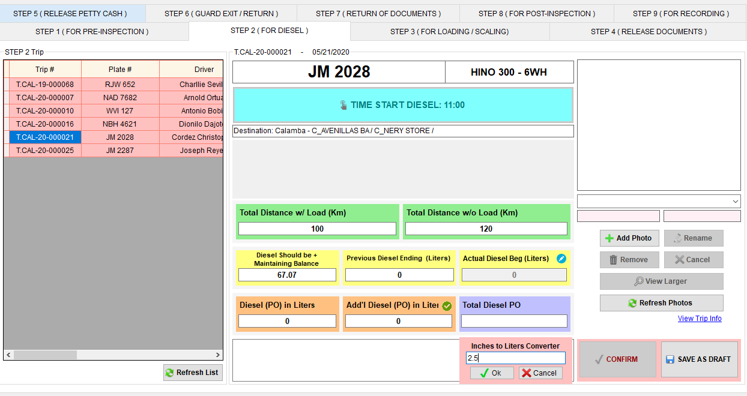

Dito i-input ung sukat ng diesel in inches.

Then, click OK button to convert.

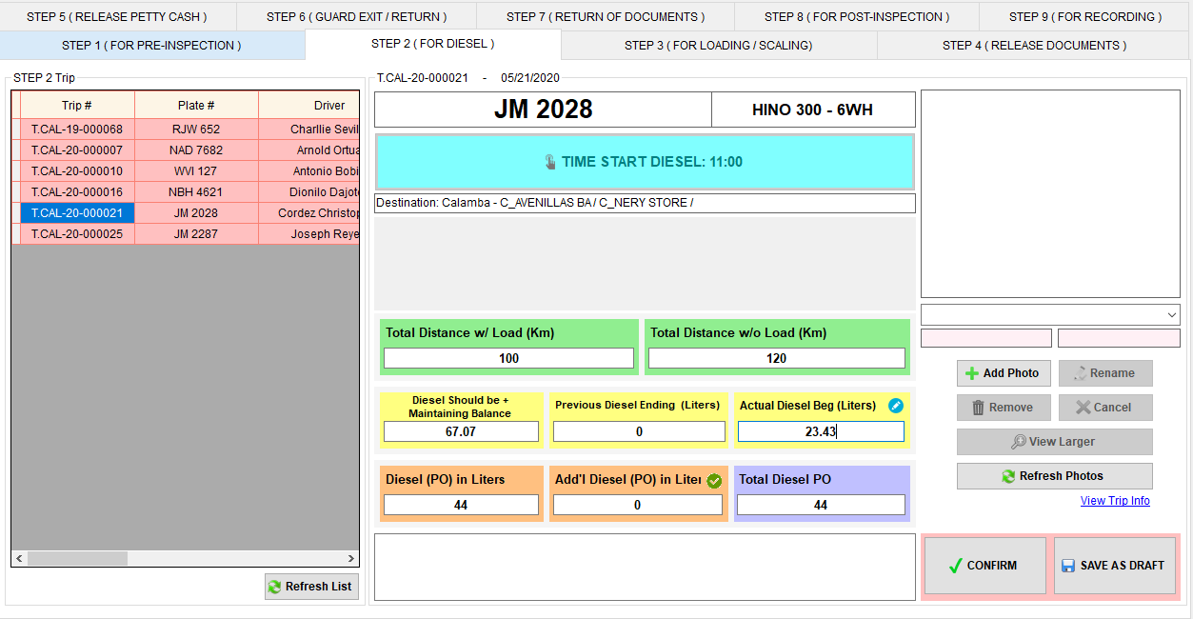

Ito na ung converted na sukat in Liters

Step 8. Note: Pwede pa din ung direct input ng sukat in liters.

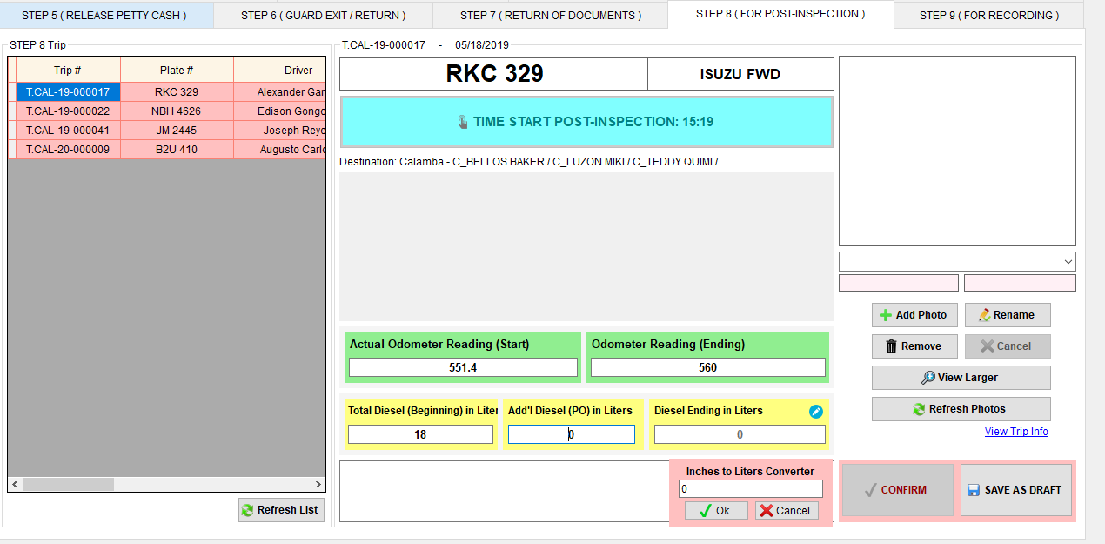

Click this icon to show

the converter

Click Cancel button to cancel the conversion

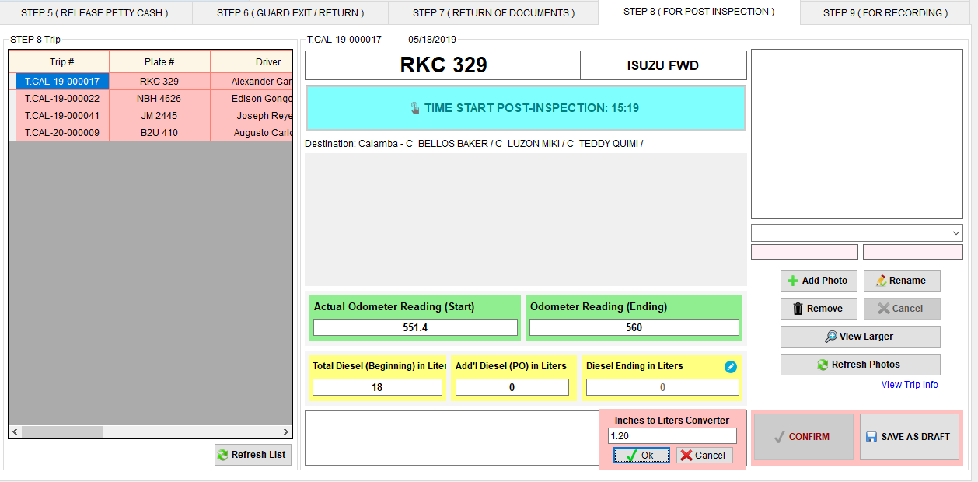

Dito i-input ung sukat ng diesel in inches.

Then, click OK button to convert.

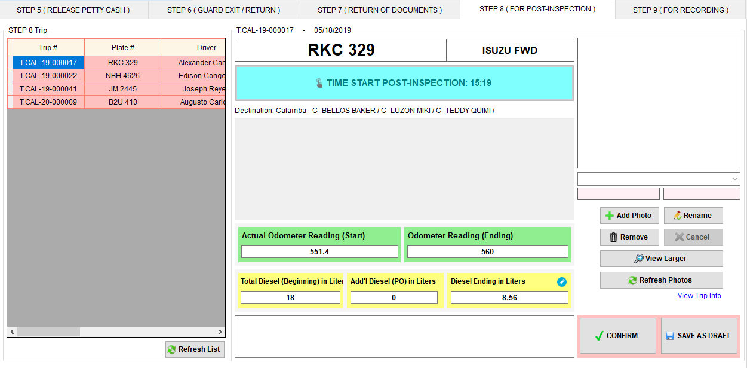

Ito na ung converted na sukat in Liters

1. Dito tignan kung ilang diesel ang dapat nasa PO Diesel / Withdrawal Slip.

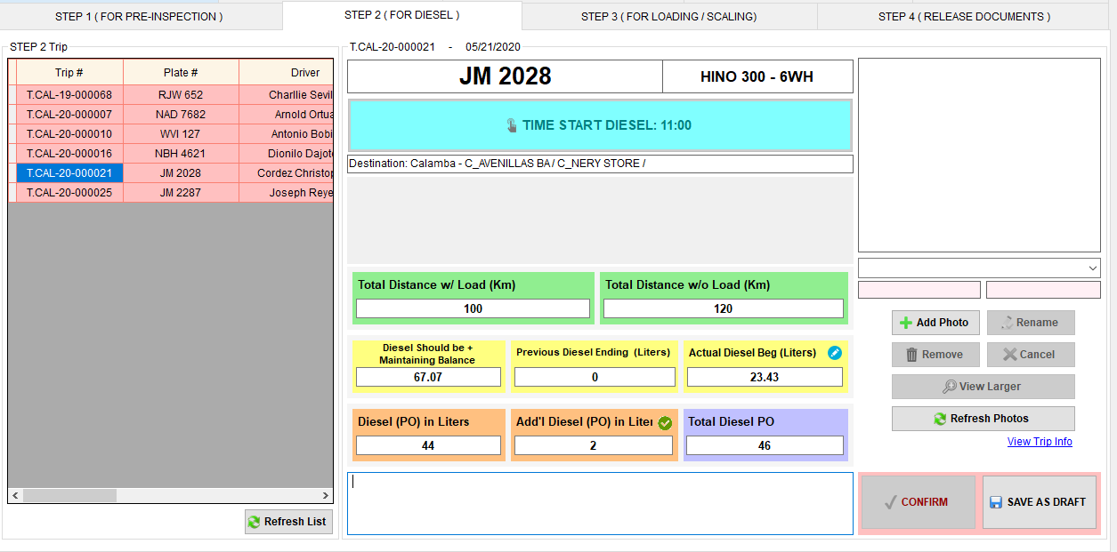

1. New design pag nag view ng step.

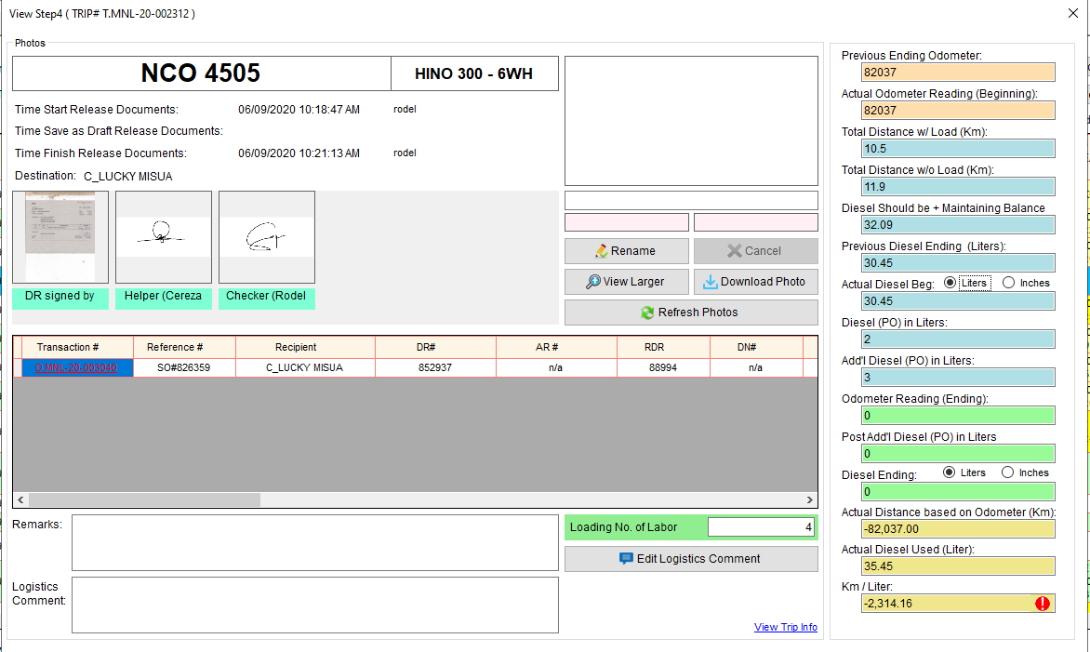

Nilipat din sa unahan yung DR#

1. View Larger – nag iiba iba ng location ung image kada steps, para mas madali mai-compare ang attachments sa input sa fleet.

In Step 1

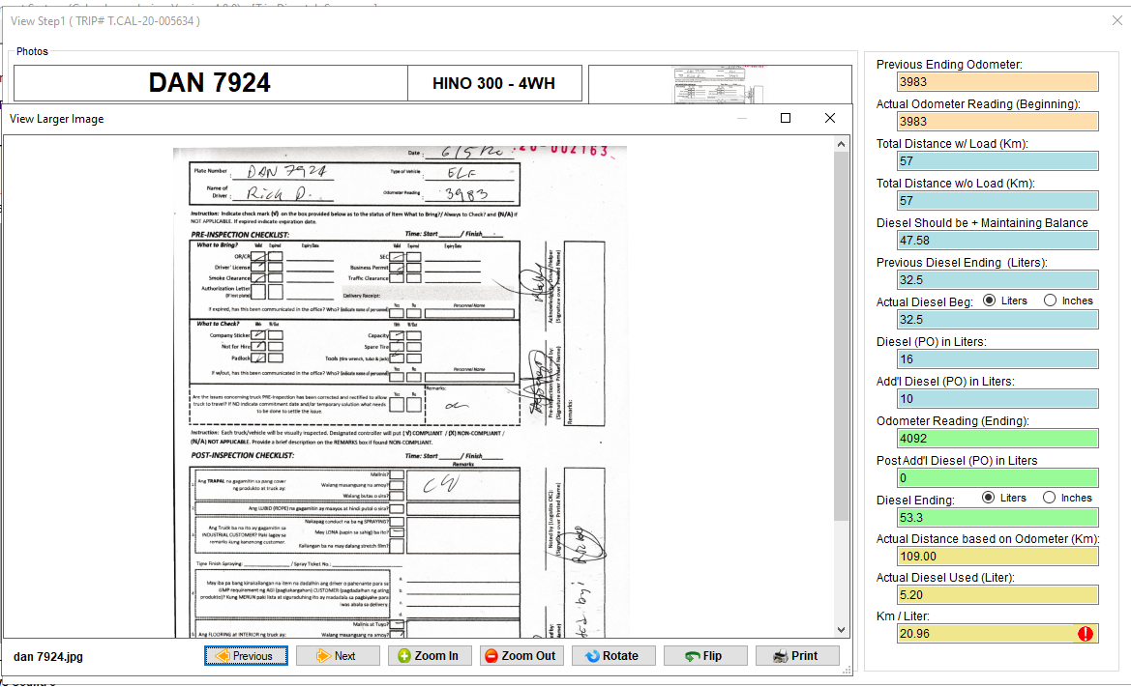

In Step 2

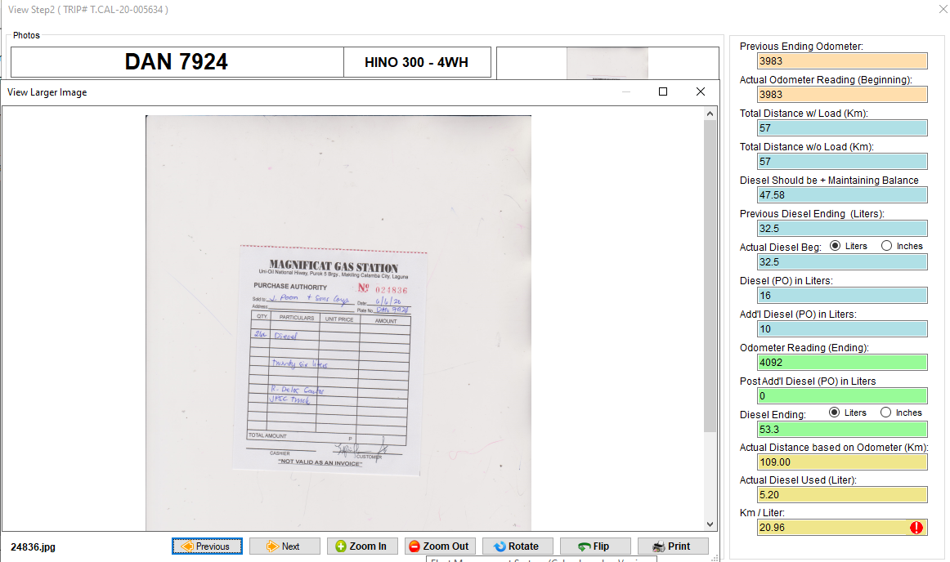

In Step 3

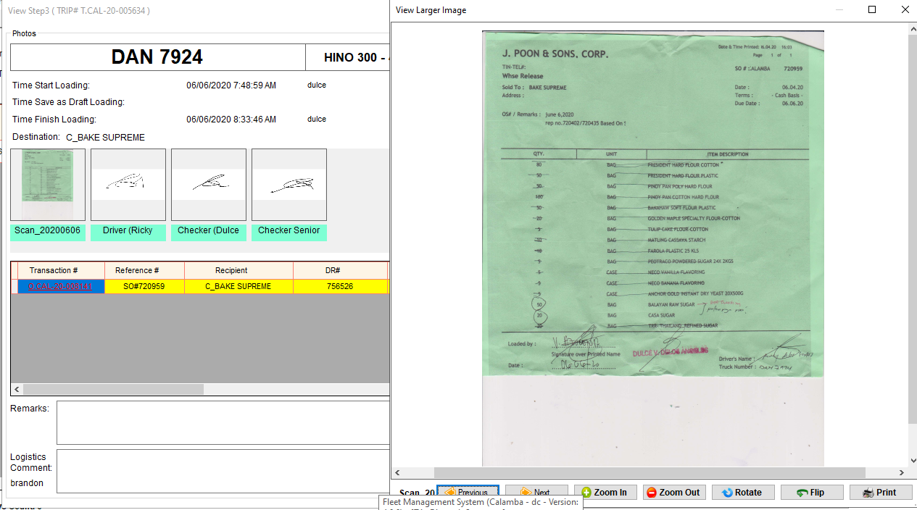

In Step 4 and 7

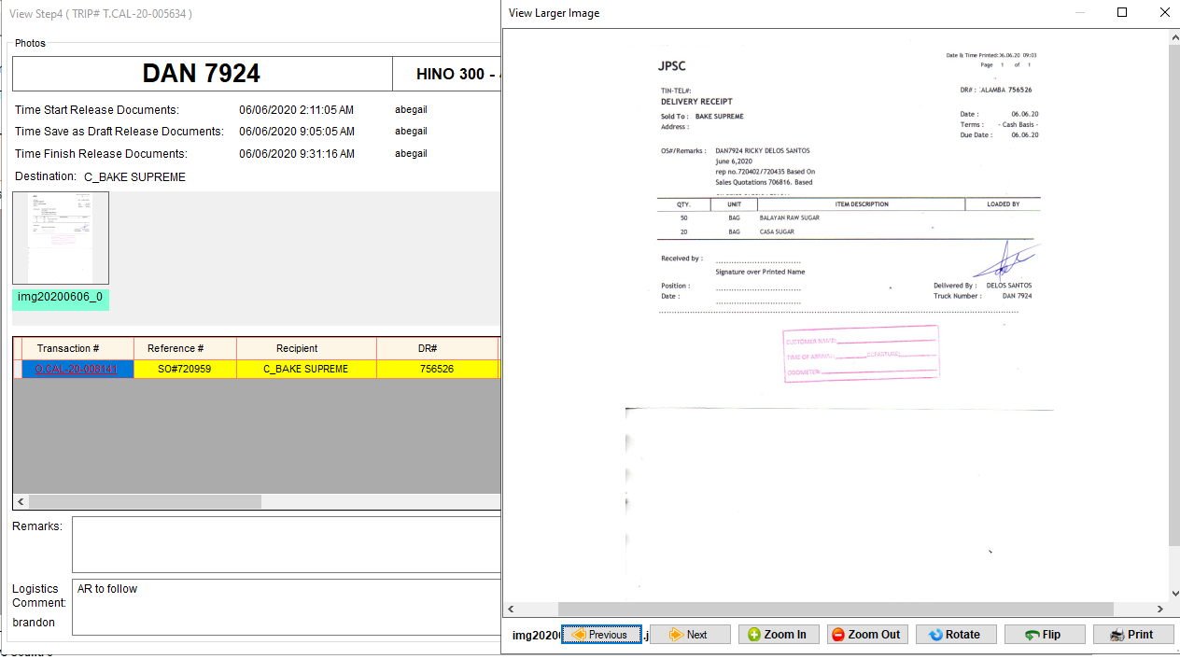

In Step 5

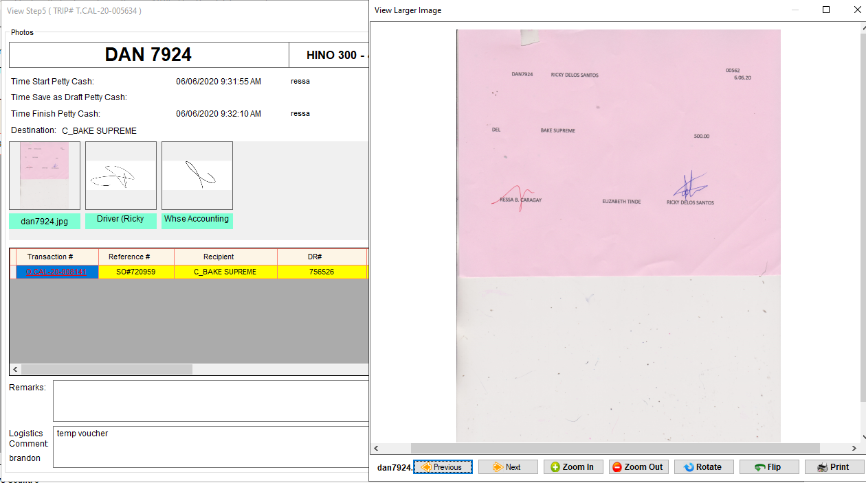

1. Make sure na kapag nag arrival to other whse, I click yung CONFIRM ARRIVAL TO OTHER WHSE button.

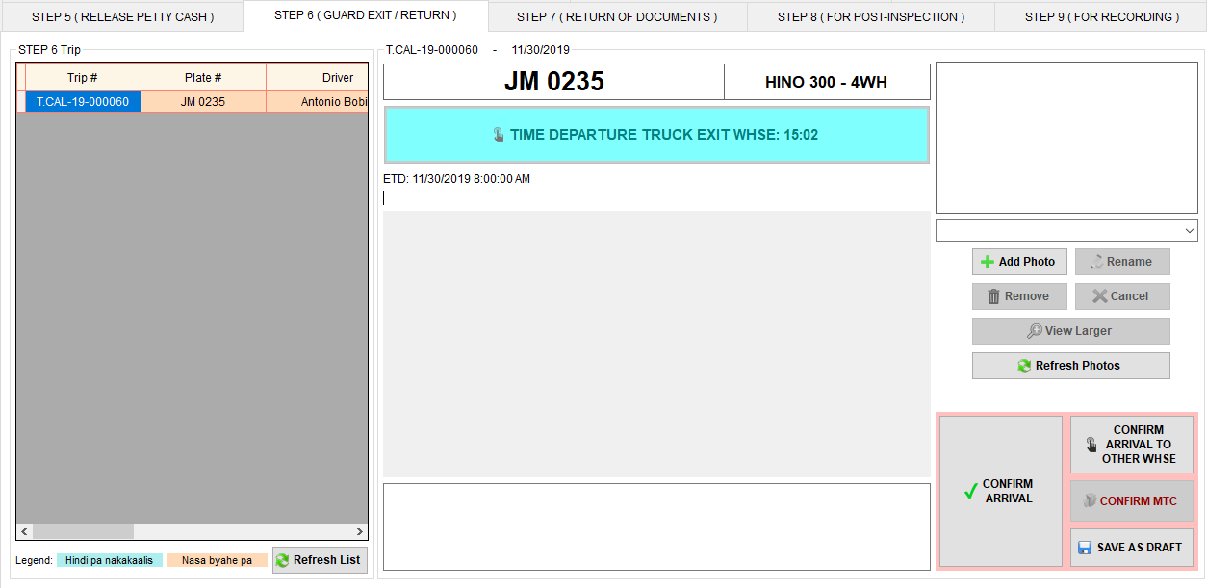

Ito ang i-click pag sa whse ninyo nag arrived ung truck

Ito ang i-click pag sa ibang whse nag arrived ung truck

* Pag click ng CONFIRM ARRIVAL TO OTHER WHSE button, need mag select n whse kung saan nag arrived ang truck.

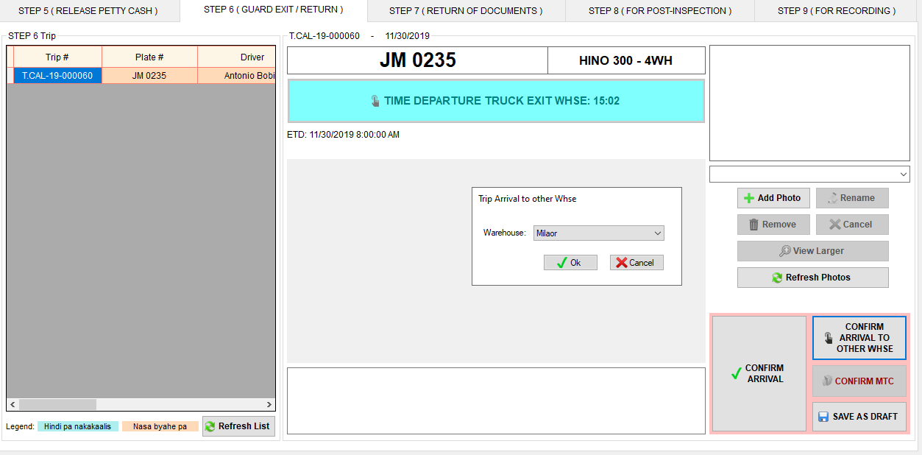

Select whse kung saan nag arrived ang truck. Then, click Ok button.

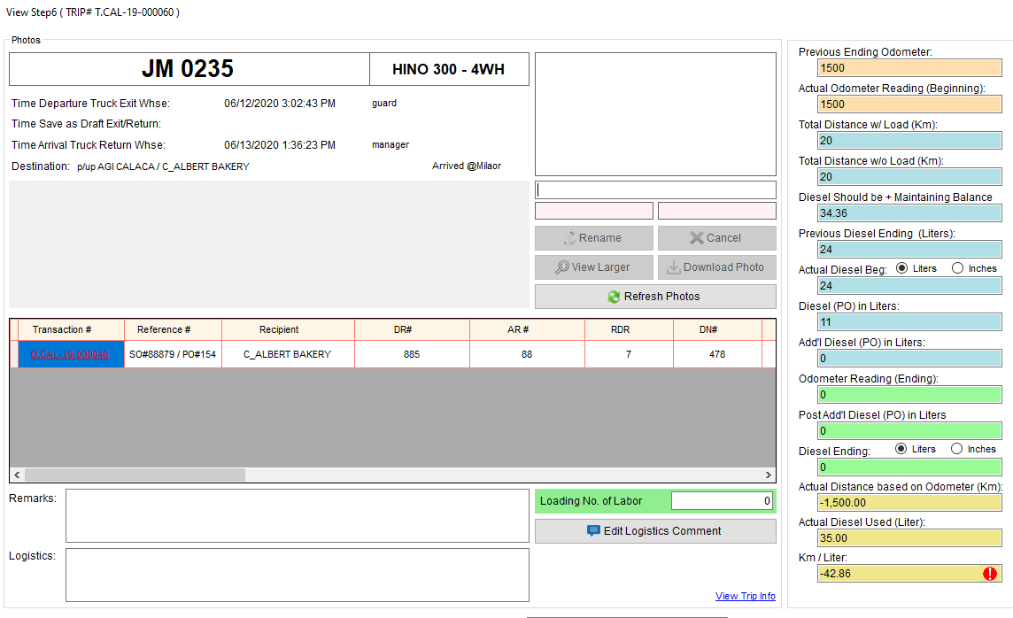

Makikita dito kung nag click ng CONFIRM ARRIVAL TO OTHER WHSE.

1. Pwede na mag view ng mga pending na trip ng Truck or Driver or Recipient.

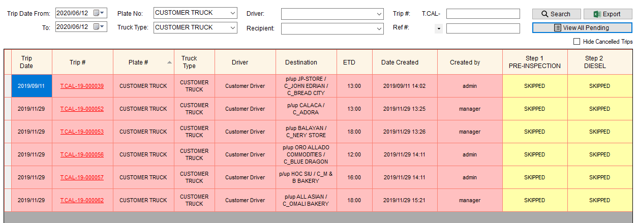

1. Input Plate No.
2. Click View All Pending button.

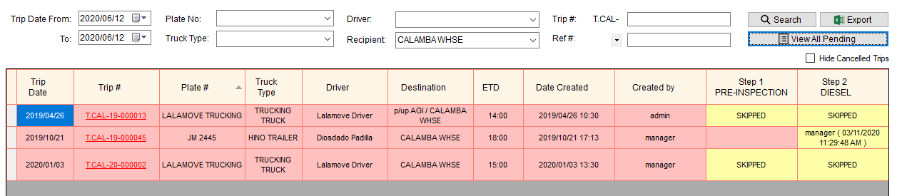

1. Input Recipient.
2. Click View All Pending button.
3. Nilipat na sa unahan ang DR# for Step 4, 7, 9.

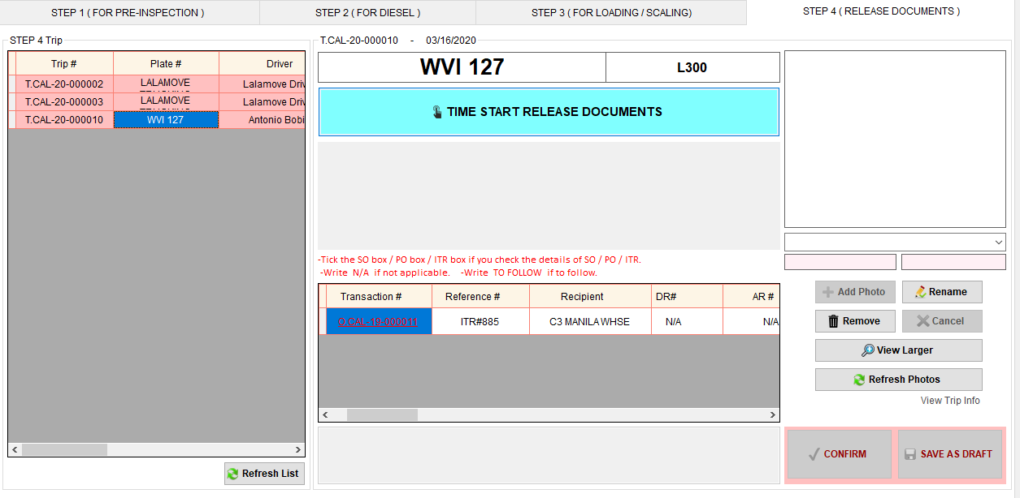

1. 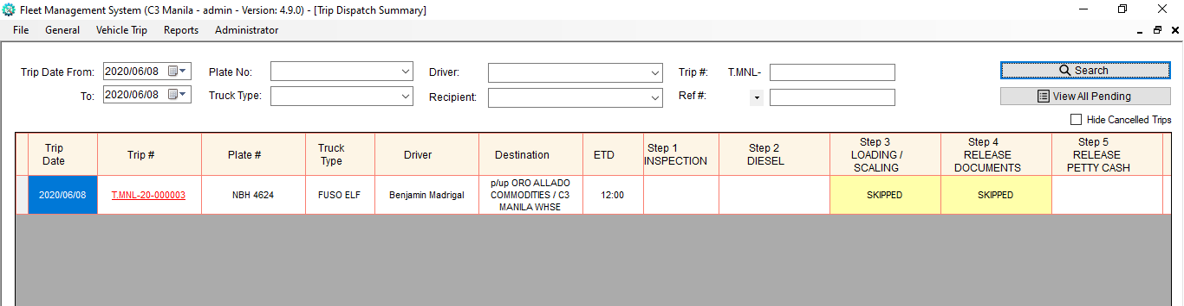C3 – pag pup ORO ALLADO naka skipped Step 4
2. Calamba – May access na ang account ng diesel controller sa Step 6.
3. Calamba / Naga

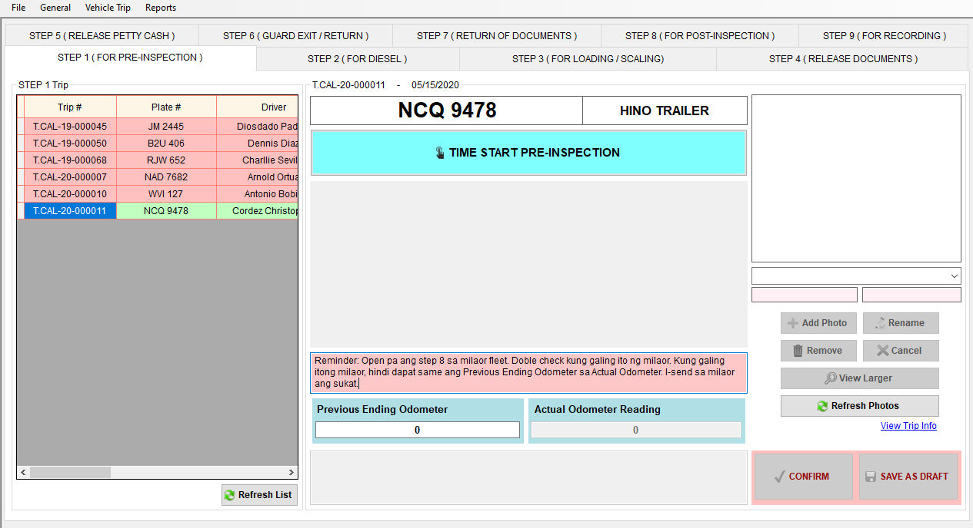If ang byahe is Calamba to Naga or vice versa, at open pa ang step 8 sa fleet kung saan galing ang truck, may lalabas na reminder para i-send ang sukat ng odometer at diesel dahil madalas hindi naisesend.

1. Logistics – change oil ng truck pwede na mag import to excel para mag update.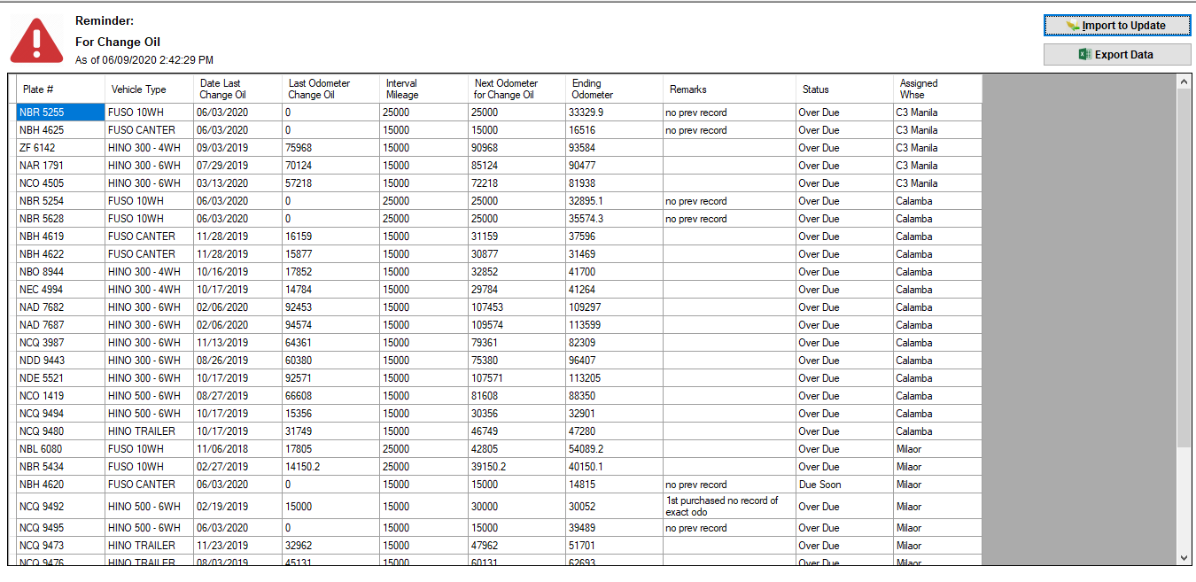
2. Logistics – pwede na macheck kung anung truck ang walang trip sa fleet

Note: Date of trip is today and hindi counted ung trip ng truck kung hindi pa naka departure sa fleet.

* Go to Report Menu, then click Trucks w/ Trips Today
* Filter trucks by selecting assigned warehouse
* Can filter also if you want with trip only
* Then, click Generate button

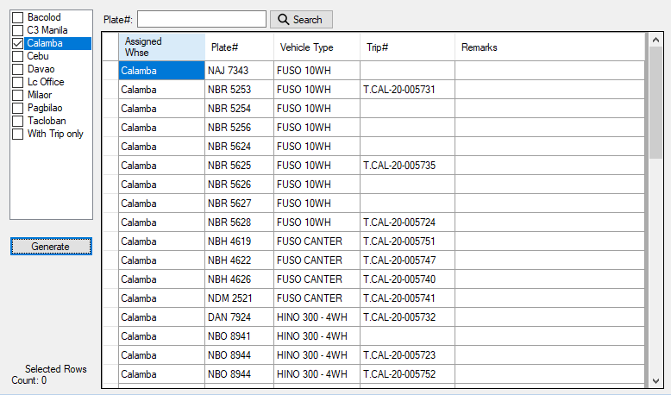

1. Logistics – Pending Trips with Steps

* Go to Report Menu, then click Trucks w/ Trips Today (dito ko din nilagay saying space ehh)
* 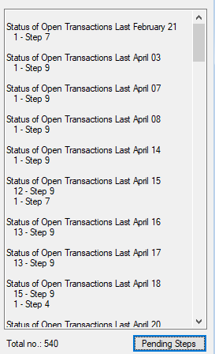Click Pending Steps button

1. Logistics – Trip Schedule Report

* Go to Report Menu, then click Trip Schedule Report
* Can filter data
* Click Ok button

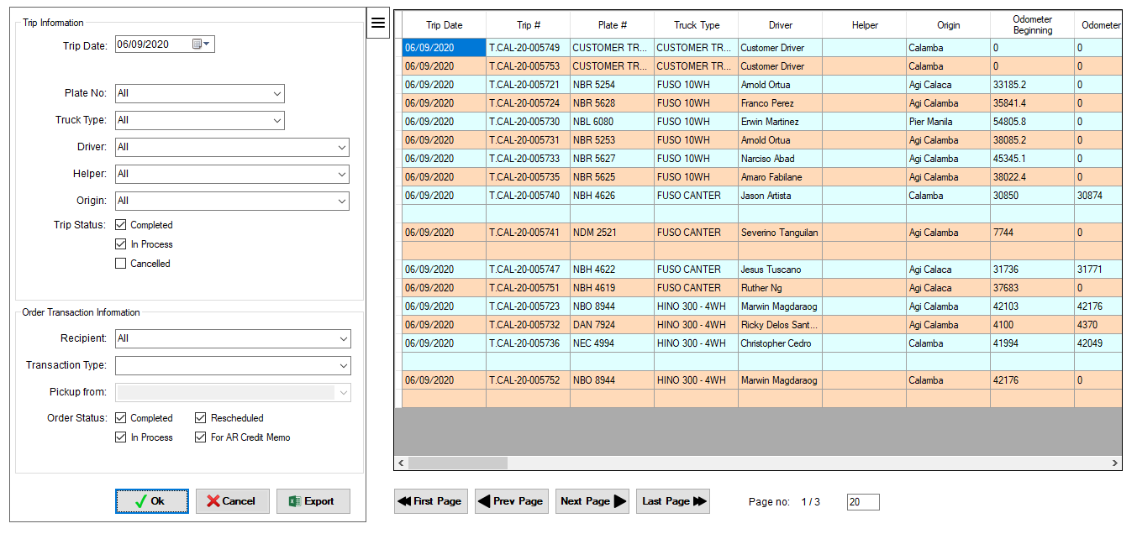

Click to hide filter

1. 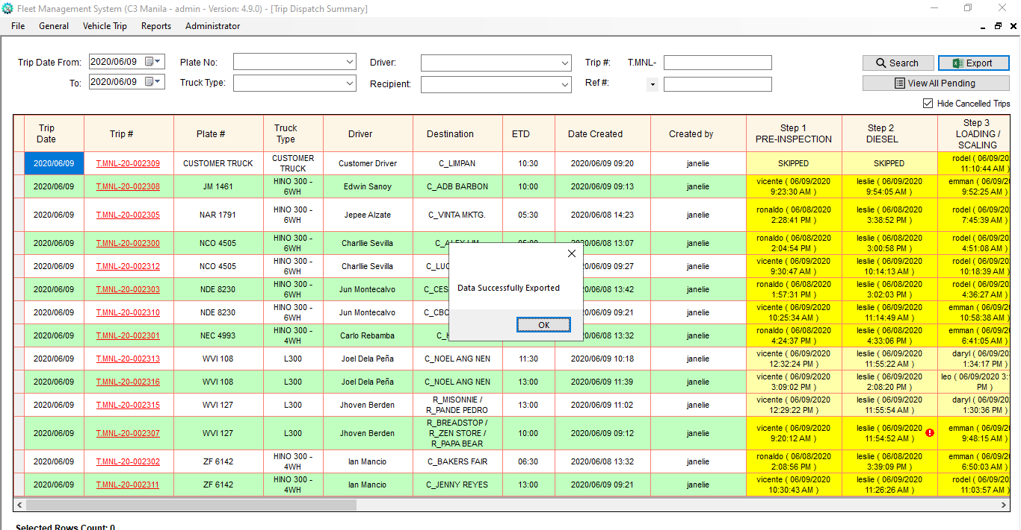Logistics – Export Trip Dispatch Summary

